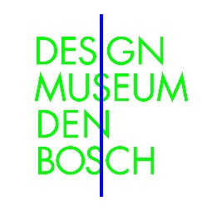

**Alle posters door Verkerke Reprodukties**

Credit: Verkerke Reprodukties

|  |  |  |  |
| --- | --- | --- | --- |
|  |  |  |  |
|  |  |  |  |

**Alle tentoonstelling foto’s door Ben Nienhuis**

Credit: Foto Ben Nienhuis

|  |  |  |  |
| --- | --- | --- | --- |
|  |  |  |  |
|  |  |  |  |