

**Alle teamfoto’s door Sander Vermeer**

Credit: Foto Sander Vermeer

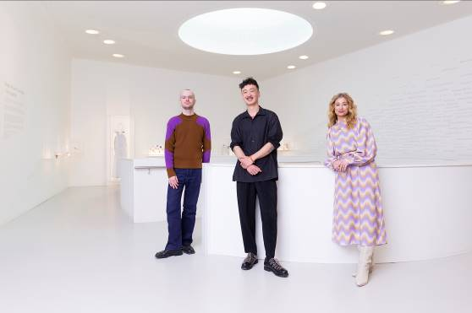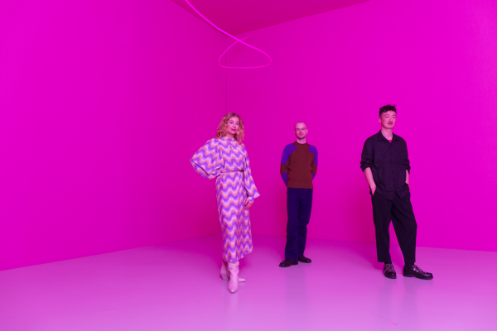

**Alle presentatiefoto’s door Ben Nienhuis**

Credit: Foto Ben Nienhuis

|  |  |  |  |
| --- | --- | --- | --- |
|  |  |  |  |

