Beeldcredits - A Digital Nature - DEMO
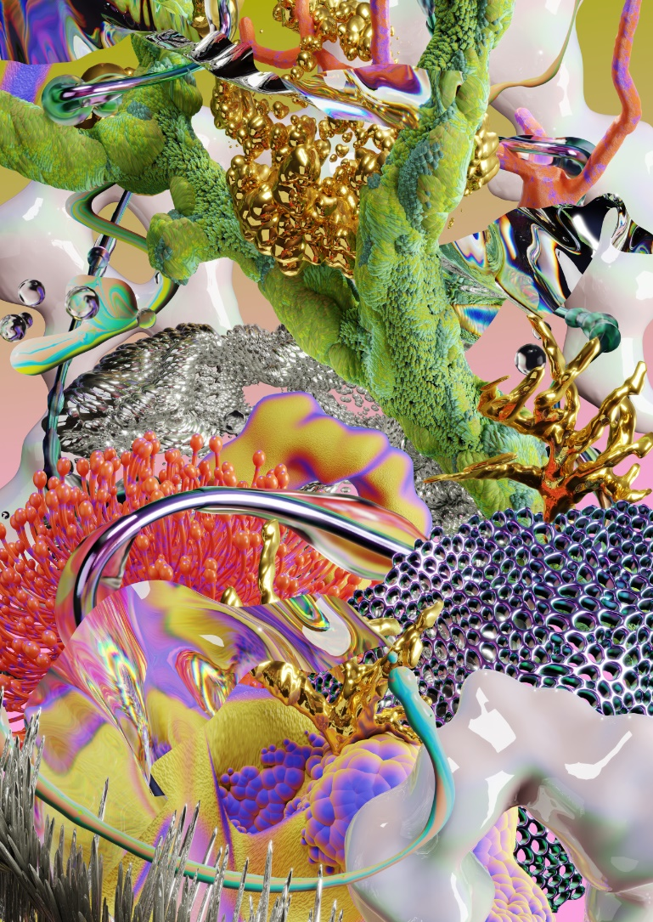 | SeaBottom from ALANKONUOTIO
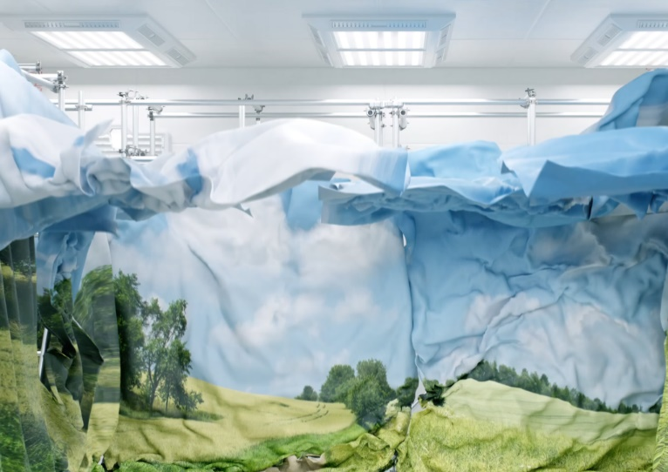 | Still from Printed Nature from Angelina Toros
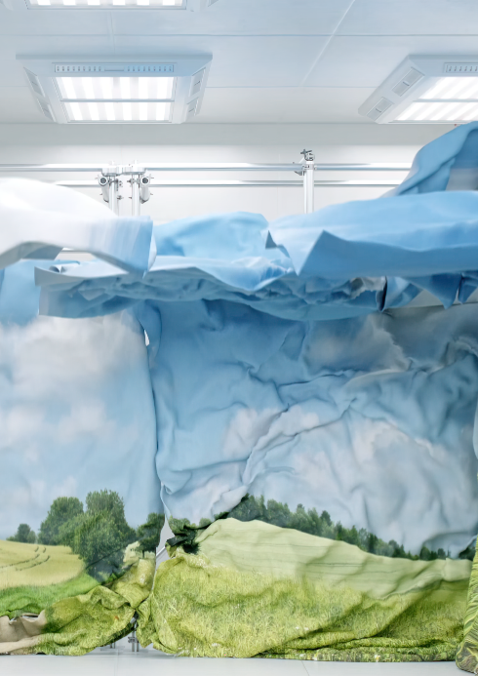 | Still from Printed Nature from Angelina Toros
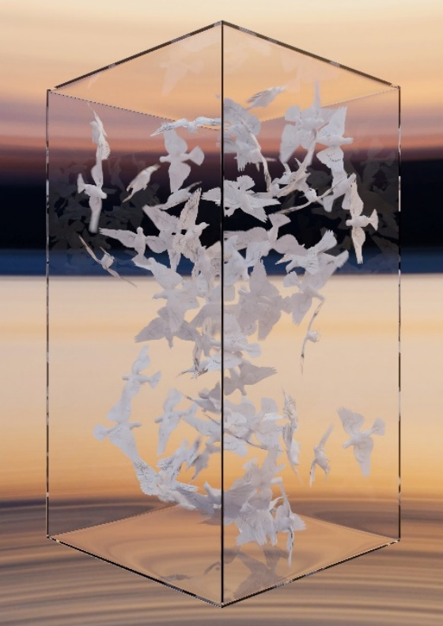 | Still from Peace Does Not Equal Freedom van Timo Lenzen
