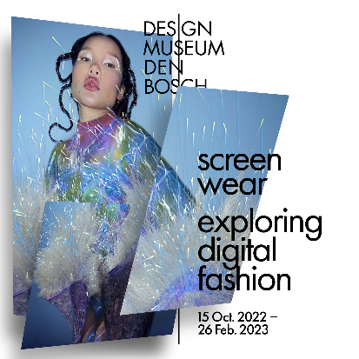

Screenwear – Exploring Digital Fashion.

From 15 October at the Design Museum Den Bosch

From 15 October onwards, you can immerse yourself in the exhibition Screenwear – Exploring Digital Fashion. Discover the latest generation of fashion designers and come face-to-face with hyperrealistic digital models. Use the digital fitting mirror to try on pieces from the museum’s collection and test out the latest filters by James Merry and Inès Alpha. Above all, though, you’ll find answers to your questions about digital fashion. What is it exactly and how do you go about wearing it? Who is shaping digital fashion? And what do these developments mean for the fashion industry?

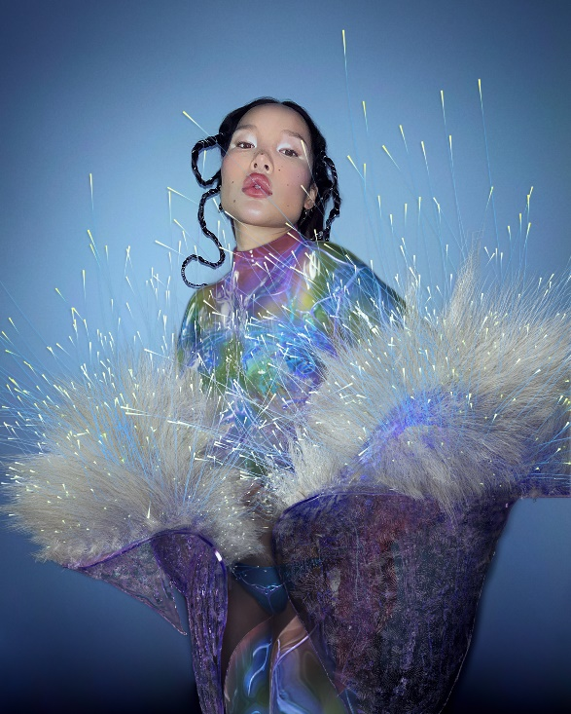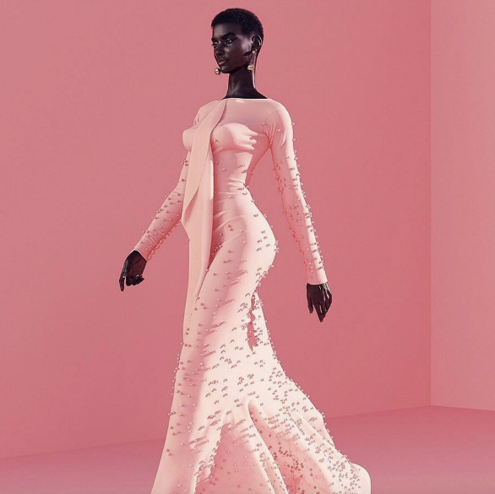
Left: Auroboros, Atokirina jacket and Mandrake bodysuit, 2021
Right: The Diigitals, Shudu Gram, 2017

Not science fiction
Digital fashion has long since moved out of the realm of science fiction. Almost imperceptibly, fashion made of pixels rather than fabrics has become part of many people’s daily lives. We are slowly moving towards the metaverse, the virtual world of the future, in which our physical environment will merge with the digital one. There is already a wide range of choices for the digital wardrobe you’ll need for that: from digital couture you can buy as NFTs to designs for your social media, which transcend the laws of nature. Not to mention collectibles from prominent fashion houses to wear in your favourite game.
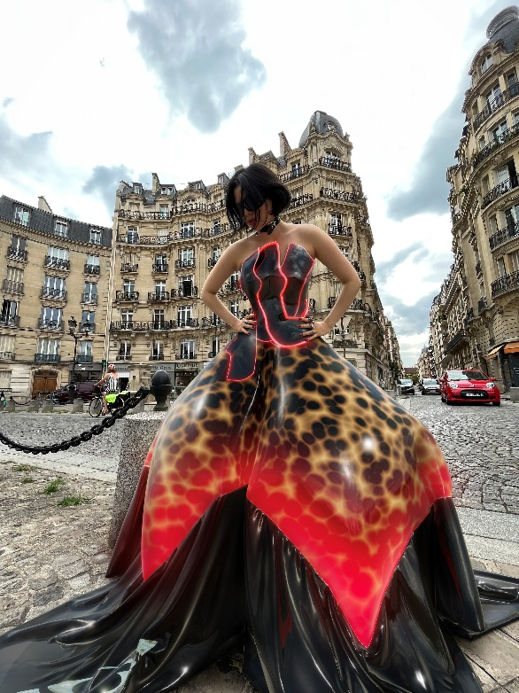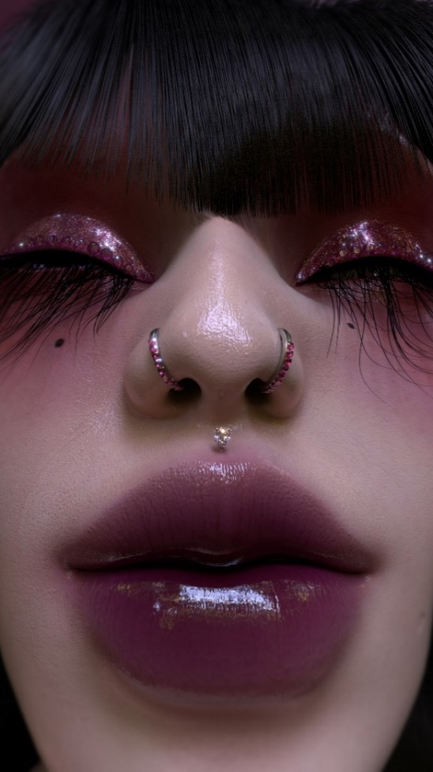
Left: Tribute Brand, BICA Dress, 2021
Right: Carol Civre, CGI Portrait, 2020 (revised 2022)

From futuristic fashion designs to digital collections
Screenwear – Exploring Digital Fashion presents the most varied and groundbreaking of these designs, while exploring the short history of an emerging phenomenon. From the futuristic fashion designs of Auroboros and the digital collections of The Fabricant to the first non-binary avatar from the Institute of Digital Fashion and the hyperrealistic supermodel Shudu: in the digital world too, how you present yourself says everything about who you are, and who you could or would like to be.
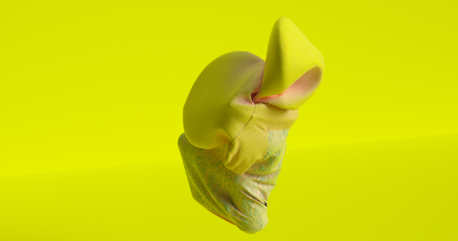
Zeitguised, Void Season, 2016

The exhibition
The exhibition begins with a timeline to guide you through a brief history of digital fashion from the early 1980s to the recent Covid years, in which the development of digital fashion shifted up a gear. A Digital Fit then looks at the different ways you can wear digital fashion, including Augmented Reality, direct-to-avatar-purchase and digital tailoring. A Digital Self, meanwhile, is all about shaping your digital identity: how do you want to look in a world where anything is possible? In which the physical reality of your own body and the laws of nature no longer apply? The blurring of boundaries between physical and virtual design is addressed by the theme On the Horizon. Here you can see early examples of digital fashion, such as the work of the German design studio Zeitguised and the Dutch digital fashion house The Fabricant. Groundbreaking Innovations tells you more about the technologies used to make digital fashion: just like traditional couture, designing and producing virtual fashion takes a great deal of time, energy and knowledge. Another unique aspect of digital fashion is the role it plays in the world of gaming. The Community Building theme therefore explores digital fashion in online games and how it is benefiting the fashion industry. The exhibition rounds off with its final theme: World of Possibilities, which presents an ever-growing selection of the most current designs.
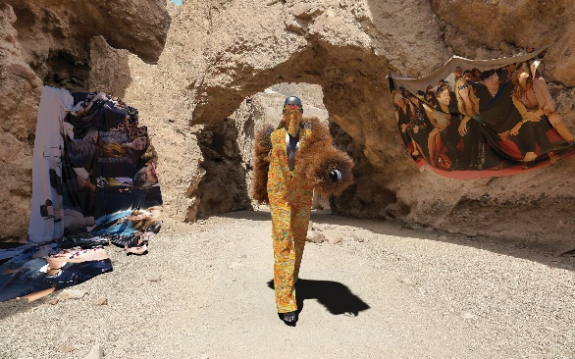
The Fabricant, DEEP, 2018

Featuring work by
The Diigitals, Auroboros, The Fabricant, Tribute Brand, James Merry, Inès Alpha, Reblika, Frederik Heyman, Institute of Digital Fashion, Harriet Davey, Stacie Ant, Tony Murray, Carol Civre, Zeitguised, Studio PMS, Stephy Fung, Scarlett Yang, Mutani, Stefan Kartchev, Code Couture, 4DR Studios in collaboration with Leevi Ikäheimo, Elizaveta Federmesser & Carl Rethman, and Hanifa.
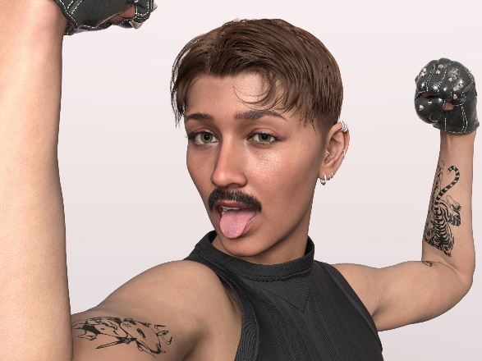
IoDF X DAZ3D, Catty 8.1, 2022

