Beeld / image | Bijschrift / credit line
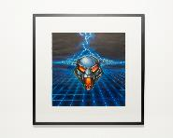 | Tekening, EarthQuake II - The Ultimate Hardcore Collection, Victor Feenstra, 1995. Foto door Annabel Miedema.  Drawing, EarthQuake II - The Ultimate Hardcore Collection, Victor Feenstra, 1995. Picture by Annabel Miedema.
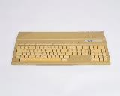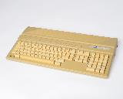 | Computer, Atari 520ST, microcomputer, serienr. A1 751 4024279, Atari Inc. 1978. Foto door Annabel Miedema.  Computer, Atari 520ST, microcomputer, serial no. A1 751 4024279, Atari Inc. 1978. Picture by Annabel Miedema.
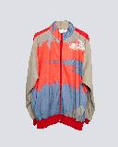 | Kleding, Trainingspak (incl. broek), Australian, jaren 90. Foto door Annabel Miedema.  Clothing, Tracksuit (incl. pants), Australian, 1990s. Picture by Annabel Miedema.
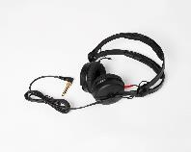 | Hoofdtelefoon, Sennheiser HD25, Sennheiser electronic GmbH & Co. KG, 1988. Foto door Annabel Miedema.  Headphones, Sennheiser HD25, Sennheiser electronic GmbH & Co. KG, 1988. Picture by Annabel Miedema.
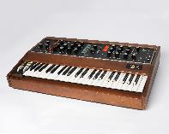 | Synthesizer, Minimoog synthesizer, serienr. 10908, Moog Music Inc. 1976. Foto door Annabel Miedema.  Synthesizer, Minimoog synthesizer, serial no. 10908, Moog Music Inc. 1976. Picture by Annabel Miedema.
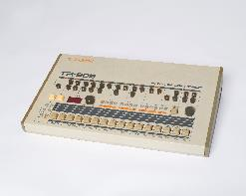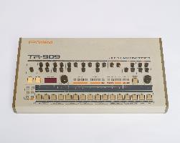 | Drumcomputer, Roland TR-909, Tadao Kikumoto, Makoto Muroi, Atsushi Hoshiai, "Mr Ou", 1983. Foto door Annabel Miedema.  Drum computer, Roland TR-909, Tadao Kikumoto, Makoto Muroi, Atsushi Hoshiai, "Mr Ou", 1983. Picture by Annabel Miedema.
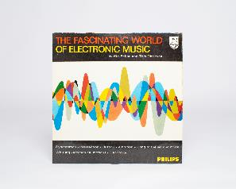 | Vinyl, The Fascinating World of Electronic Music, Tom Dissevelt, Kid Baltan, 1962. Foto door Annabel Miedema.  Vinyl, The Fascinating World of Electronic Music, Tom Dissevelt, Kid Baltan, 1962. Picture by Annabel Miedema.
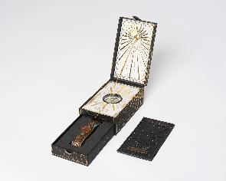 | Toegangskaart, Tomorrowland, Reflection of Love, 2020. Foto door Annabel Miedema.  Entrance ticket, Tomorrowland, Reflection of Love, 2020. Picture by Annabel Miedema.
Alle tentoonstellingsfoto’s zijn gemaakt door Ben Nienhuis

