Credits Design voor de planeet.
Image/beeld
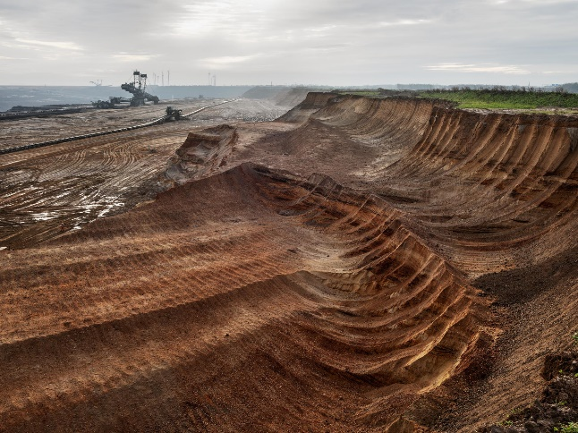 | Coal Mine #1, North Rhine, Westphalia, Germany, 2015. Edward Burtynsky, courtesy Flowers Gallery, London / Nicholas Metivier Gallery, Toronto
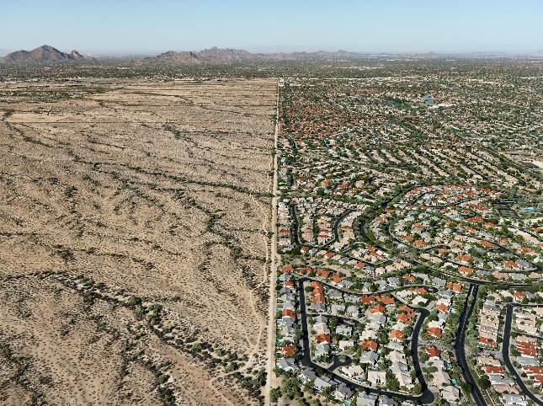 | Salt River Pima-Maricopa Indian Reservation-Scottsdale, Arizona, USA, 2011. Edward Burtynsky, courtesy Flowers Gallery, London / Nicholas Metivier Gallery, Toronto
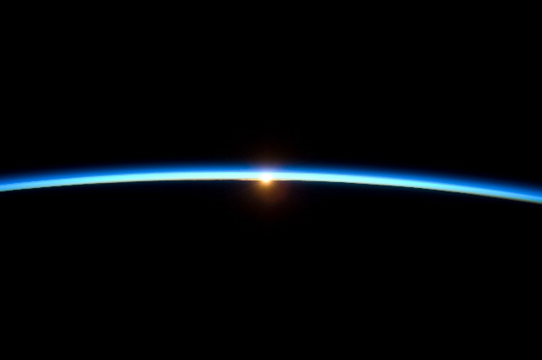 | Thin Blue Line, November 25, 2009. NASA.gov
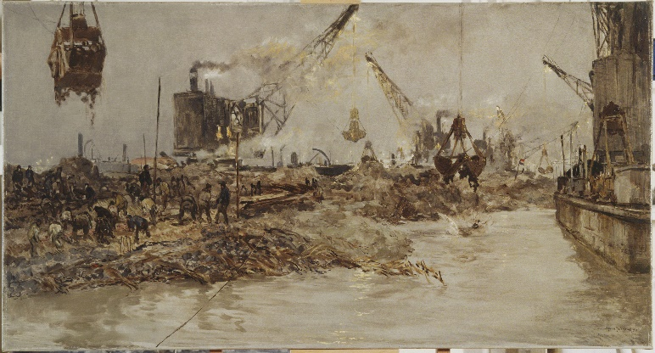 | Sluiting Middelgronden, Johan Hendrik van Mastenbroek, 1931. Collectie Zuiderzeemuseum Enkhuizen
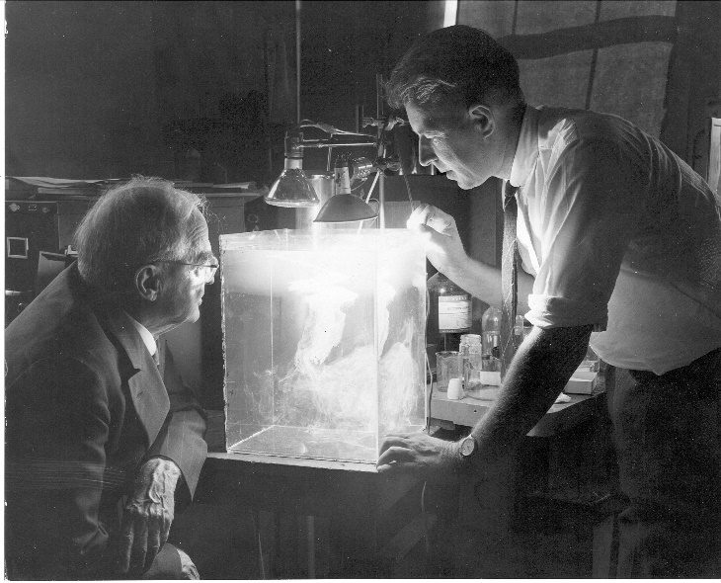 | Dr. Willis R. Whitney and Dr. Vincent J. Schaefer make an artificial cloud in a plastic box. Courtesy of Schenectady Museum; Hall of Electrical History Foundation.
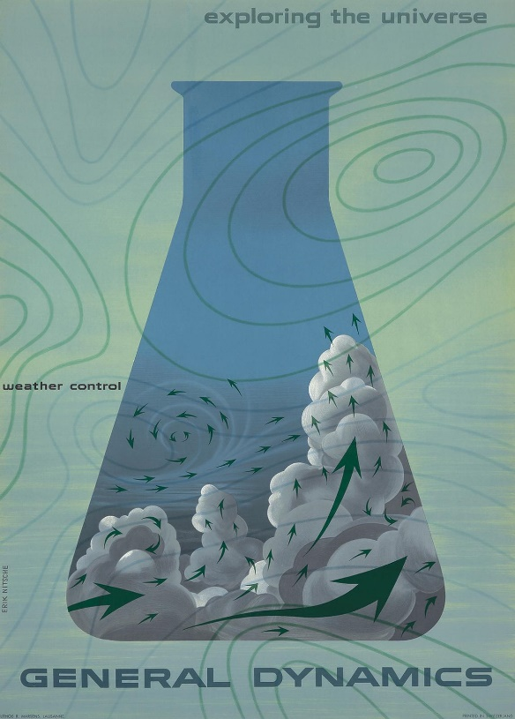 | General Dynamics Weather Control, Eric Nitsche, 1958. Poster collectie Design Museum Den Bosch

