Object information by the pictures of Trans Europa Design Express

All photos of the exhibition were taken by Peter Tijhuis. For the correct credits of the object photos, see below.
Domaine de Boisbuchet

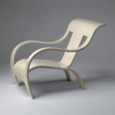
Name: Armchair
Designer: Gerald Summers
Date: 1933-34
Material: Bent and lacquered birchwood
Dimensions: 76,5 x 61 x 94 cm
Manufacturer: Makers of Simple Furniture Ltd., Londen, Groot Brittanië

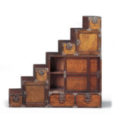
Name: Stair-chest of drawers
Designer: Unknown (Japan)
Date: Ca. 1900
Material: Wood and sheet metal
Dimensions: 154,5 x 156 x 47 cm

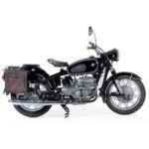
Name: R 64 S
Designer: Anonymous
Date: 1964
Material: chrome plated steel, rubber, leather and glass
Dimensions: 137 x 220 x 86 cm
Manufacturer: Bayerische Motoren Werke AG (BMW), München, Duitsland

Designmuseum Denmark
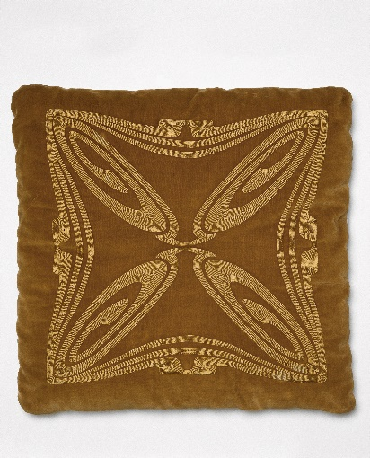
Object: Pillow in velvet (blue, green, red)
Artist: Henry van de Velde
Date: 1900
Material: Velvet
Dimensions: 54 x 54 cm

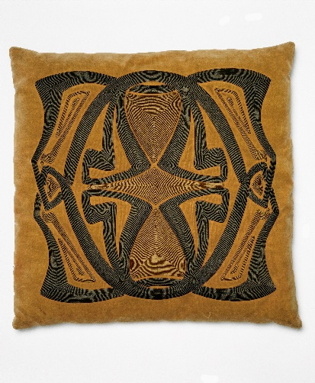
Object: Pillow in velvet (grey colours)
Artist: Henry van de Velde
Date: 1900
Material: velvet
Dimensions: 53 x 53 cm

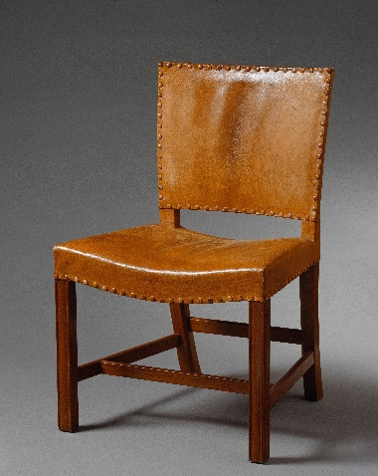
Object: Den Røde stol
Artist: Kaare Klint
Date: 1927
Material: Mahogany and oakwoord, leather
Dimensions: 46 x 58 x 89 cm

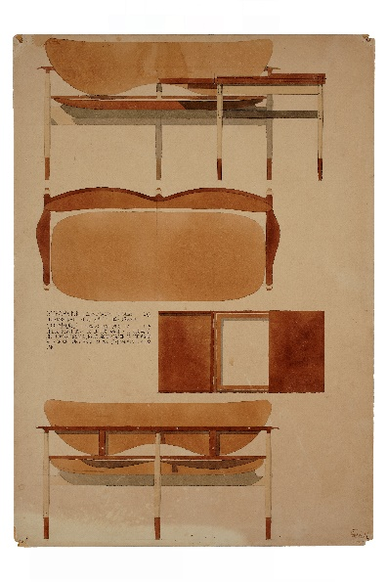
Object: Desgin drawing sofa and coffee table
Artist: Finn Juhl
Date: 1957
Material: Watercolour on paper
Dimensions: 59 x 41,5 cm

Design Museum Brussels

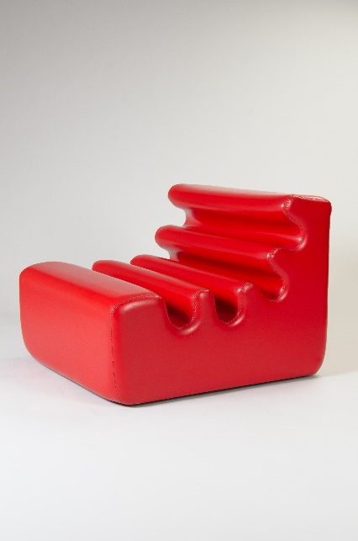
Object: Karelia
Artist: Liisi Beckmann
Date: 1966
Material: PUR, PVC, wood
Dimensions: 62 x 73,5 x 82,5 cm

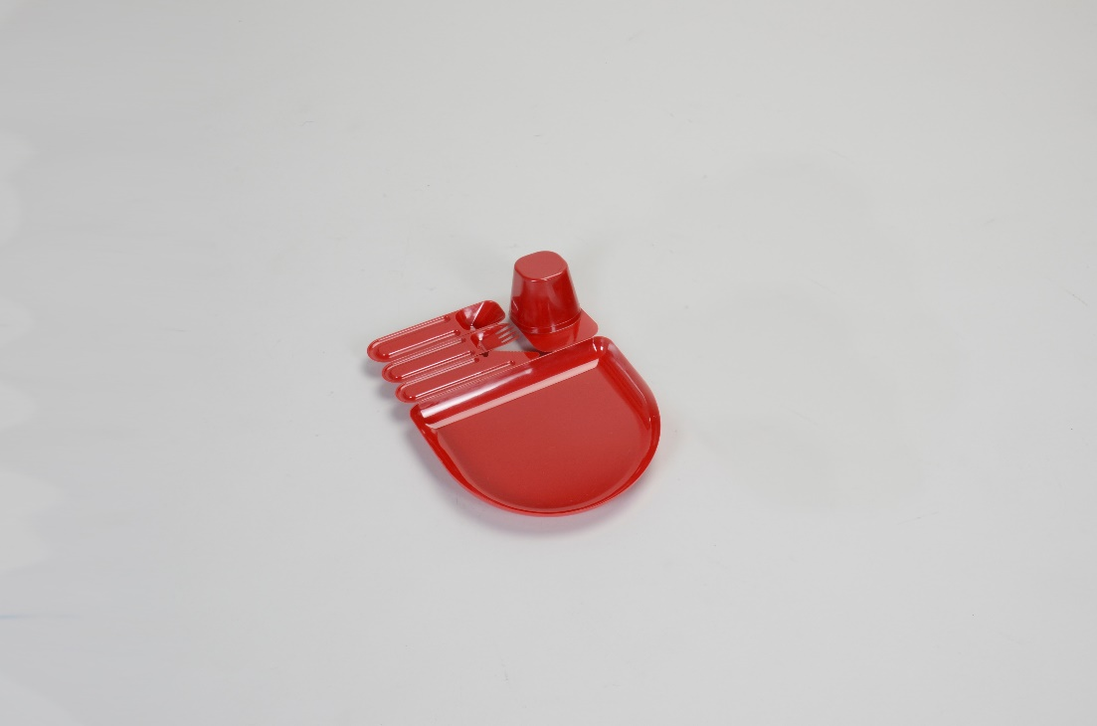
Object: Plack
Artist: Jean-Pierre Vitrac
Date: 1977
Dimensions: 6.5 x 28 x 20 cm
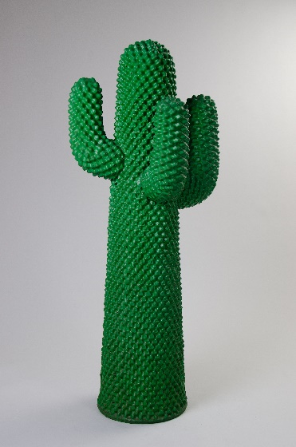
Object: Cactus
Artists: Guido Drocco & Franco Mello
Date: 1972
Dimensions: 160 x 70 x 75 cm

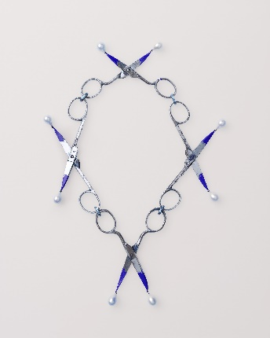
mudac Laussane
Object: Kleine Scherrenkette
Artist: Bernhard Schrobinger
Date: 2017
Credits: ©Atelier de numérisation de la Ville de Lausanne, photographe Marie Humair

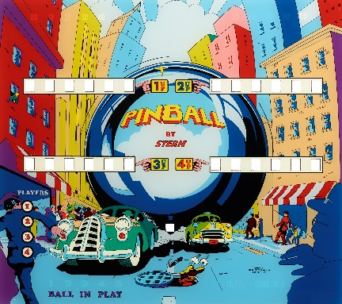
Object : Pinball
Artist: Stern pinball, Inc.
Date : 1977
Credits : ©Atelier de numérisation de la Ville de Lausanne, photographe Arnaud Conne

Object: Fleur du mal
Artist: Salvador Dalí
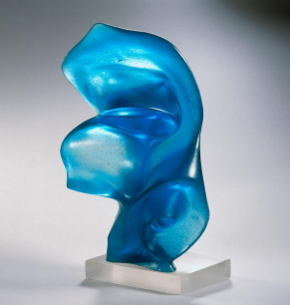
Date: 1968
Dimensions: 18 x 37 x 37 cm
Credits: ©Atelier de numérisation de la Ville de Lausanne

Triennale Milano

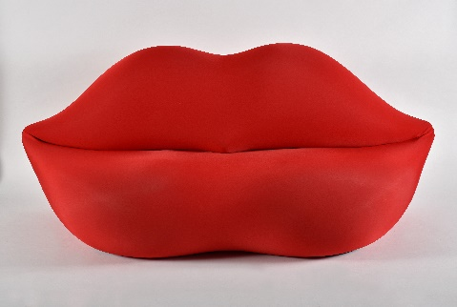
Object: without title (Bocca)
Artist: Studio65
Date: 1970
Dimensions: 212 x 85 x 80 cm
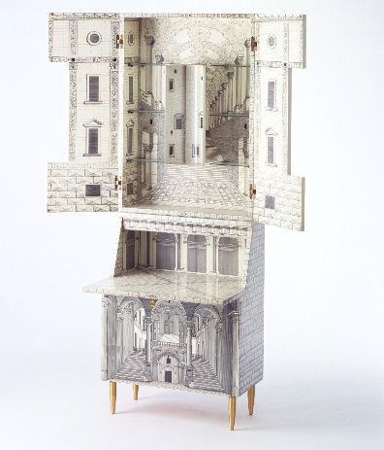
Credits: Triennale Milano_foto Frederico Manusardi

Object: Trumeau Architetettura
Artists: Piero Fornasetti & Gio Ponti
Date: Triënnale 1951
Dimensions: 81 x 39 x 219 cm
Credits: Triennale Milano_foto Amendolagine Barracchia

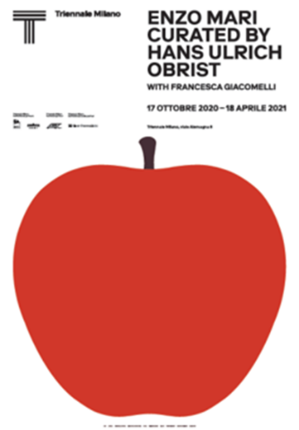
Object: poster (reproduction)
Title: Enzo Mari curated by Hans Ulrich Obrist
Artist: Norm
Date: 2020
Dimensions: 100 x 70 cm

