Object information by the pictures of Trans Europa Design Express

Domaine de Boisbuchet

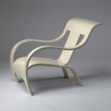
Name: Armchair
Designer: Gerald Summers
Date: 1933-34
Material: Bent and lacquered birchwood
Dimensions: 76,5 x 61 x 94 cm
Manufacturer: Makers of Simple Furniture Ltd., Londen, Groot Brittanië

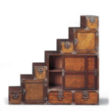
Name: Stair-chest of drawers
Designer: Unknown (Japan)
Date: Ca. 1900
Material: Wood and sheet metal
Dimensions: 154,5 x 156 x 47 cm

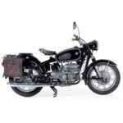
Name: R 64 S
Designer: Anonymous
Date: 1964
Material: chrome plated steel, rubber, leather and glass
Dimensions: 137 x 220 x 86 cm
Manufacturer: Bayerische Motoren Werke AG (BMW), München, Duitsland

Designmuseum Denmark
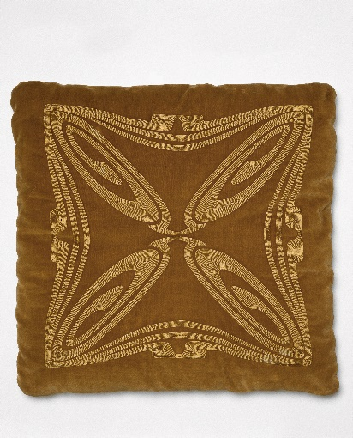
Object: Pillow in velvet (blue, green, red)
Artist: Henry van de Velde
Date: 1900
Material: Velvet
Dimensions: 54 x 54 cm

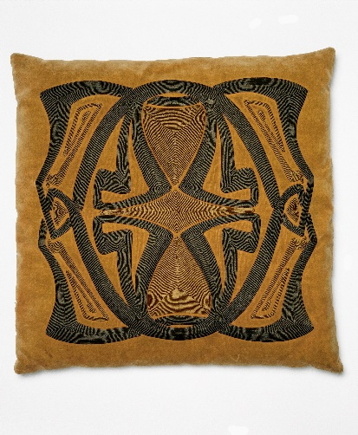
Object: Pillow in velvet (grey colours)
Artist: Henry van de Velde
Date: 1900
Material: velvet
Dimensions: 53 x 53 cm

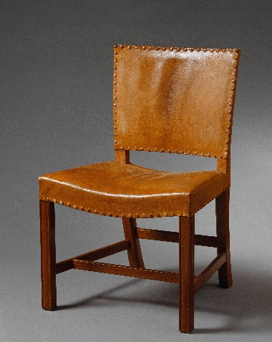
Object: Den Røde stol
Artist: Kaare Klint
Date: 1927
Material: Mahogany and oakwoord, leather
Dimensions: 46 x 58 x 89 cm

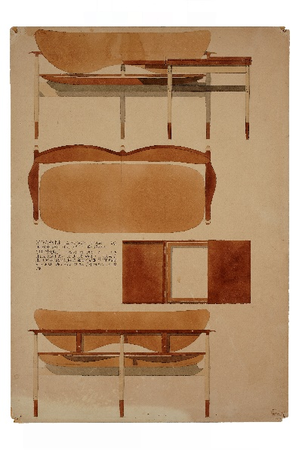
Object: Desgin drawing sofa and coffee table
Artist: Finn Juhl
Date: 1957
Material: Watercolour on paper
Dimensions: 59 x 41,5 cm

Design Museum Brussels

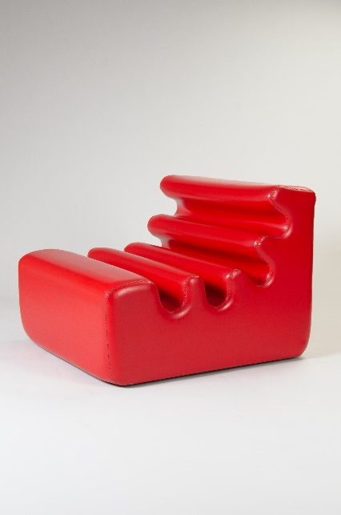
Object: Karelia
Artist: Liisi Beckmann
Date: 1966
Material: PUR, PVC, wood
Dimensions: 62 x 73,5 x 82,5 cm

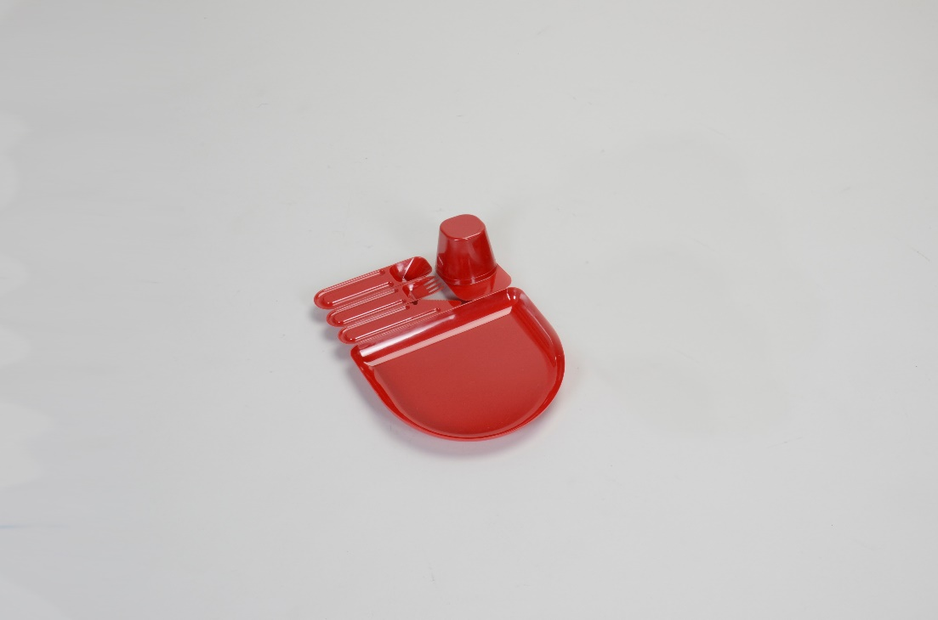
Object: Plack
Artist: Jean-Pierre Vitrac
Date: 1977
Dimensions: 6.5 x 28 x 20 cm
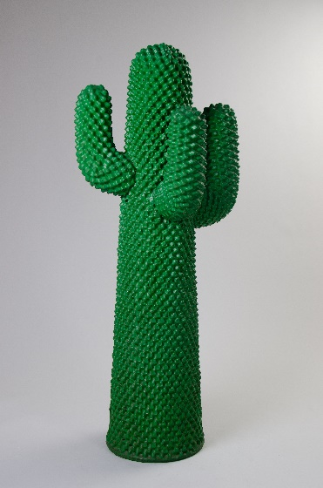
Object: Cactus
Artists: Guido Drocco & Franco Mello
Date: 1972
Dimensions: 160 x 70 x 75 cm

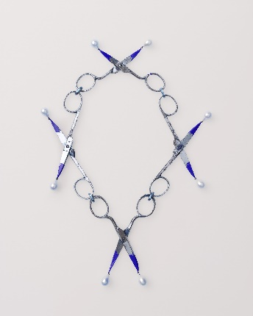
mudac Laussane
Object: Kleine Scherrenkette
Artist: Bernhard Schrobinger
Date: 2017
Credits: ©Atelier de numérisation de la Ville de Lausanne, photographe Marie Humair

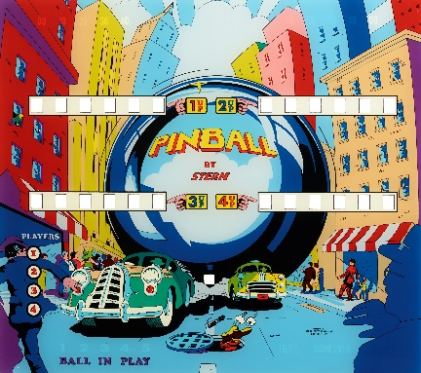
Object : Pinball
Artist: Stern pinball, Inc.
Date : 1977
Credits : ©Atelier de numérisation de la Ville de Lausanne, photographe Arnaud Conne

Object: Fleur du mal
Artist: Salvador Dalí
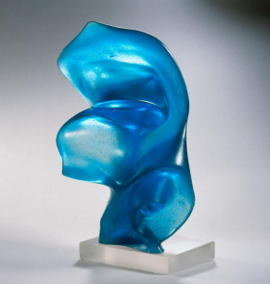
Date: 1968
Dimensions: 18 x 37 x 37 cm
Credits: ©Atelier de numérisation de la Ville de Lausanne

Triennale Milano

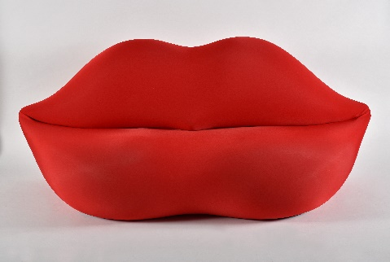
Object: without title (Bocca)
Artist: Studio65
Date: 1970
Dimensions: 212 x 85 x 80 cm
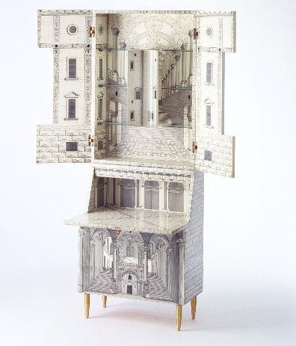
Credits: Triennale Milano_foto Frederico Manusardi

Object: Trumeau Architetettura
Artists: Piero Fornasetti & Gio Ponti
Date: Triënnale 1951
Dimensions: 81 x 39 x 219 cm
Credits: Triennale Milano_foto Amendolagine Barracchia

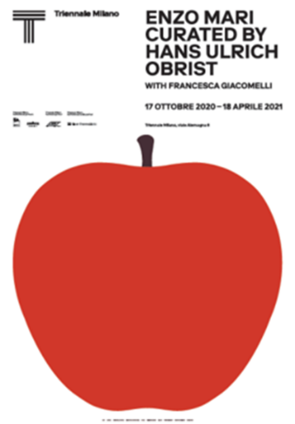
Object: poster (reproduction)
Title: Enzo Mari curated by Hans Ulrich Obrist
Artist: Norm
Date: 2020
Dimensions: 100 x 70 cm

